**FUZZING**

Fuzzing or fuzz testing is an automated software testing technique that involves providing invalid, unexpected, or random data as inputs to a computer program.

**Implementation in the todoList CI/CD pipeline:**

Tool chosen: **JavaFuzz** -> <https://github.com/fuzzitdev/javafuzz>

* Add the dependency in your maven pom.xml (not done as modifying the project’s application is not one of our goals)
* Implement the following function (not done as modifying the project’s application is not one of our goals):

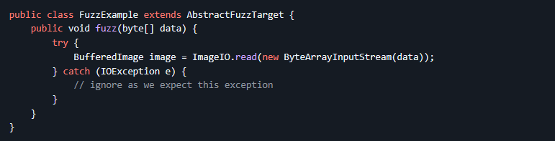

* Install java fuzzing: wget -O jacocoagent.jar <https://github.com/fuzzitdev/javafuzz/raw/master/javafuzz-maven-plugin/src/main/resources/jacocoagent-exp.jar>
* Run the fuzzing: MAVEN_OPTS="-javaagent:jacocoagent.jar" mvn javafuzz:fuzz -DclassName=fuzzing.class.test.path

**Implementation in the juiceShop CI/CD pipeline:**

Tool chosen: **jsFuzz** -> <https://github.com/fuzzitdev/jsfuzz>

* Implement the a function named “fuzz” with only one parameter, “buff”, in a js module (not done as modifying the project’s application is not one of our goals)
* Install jsFuzz in the Project with npm: npm install –g jsfuzz
* Run jsfuzz: jsfuzz ./path/to/the/specified/module corvus